 | Monday | Tuesday | Wednesday | Thursday  Spooky Halloween Party | Friday
  Morning | 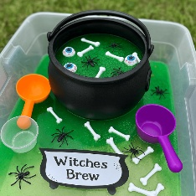 | 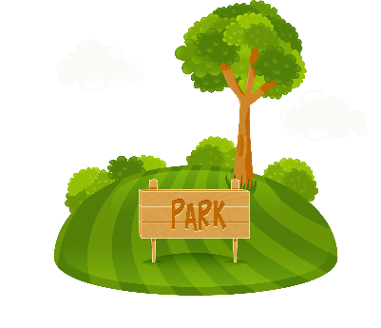 | 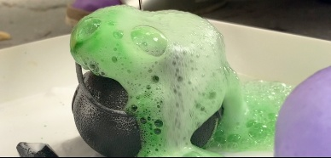  Spider wed Suncatcher  &  Bubbling Cauldron | 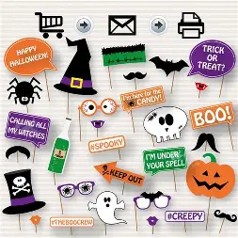 | 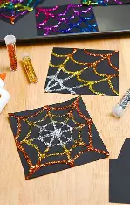
Afternoon | 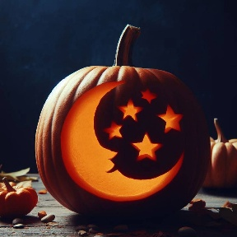  Carving pumpkins  &  Spider web slime  v | 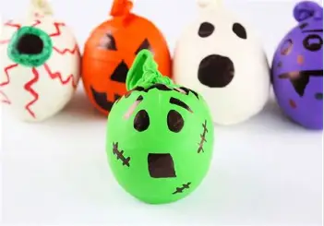  Trip to Morrisons to buy pumpkins  &  Gloopy witch’s brew  Crafty Pumpkin Spooky Stress Balls  &  DIY Pumpkin Bowling | 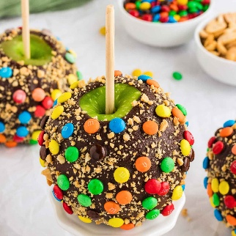 | 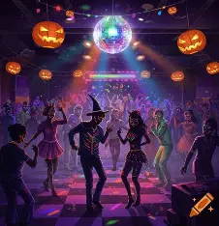  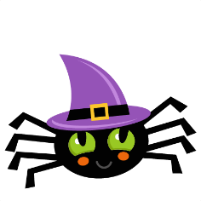  Spooky Halloween photo props  &  Halloween paper chain | 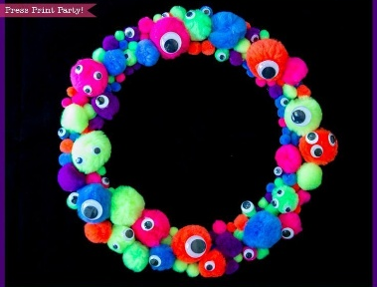  Glevum Park trip  &  Ghost Pom Pom Poppers  Glitter Spider Webs  &  Nature Art
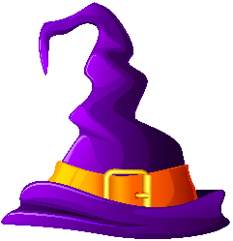  Physical activity |  | 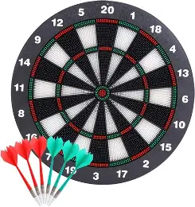 | 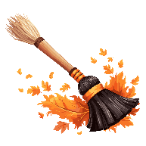  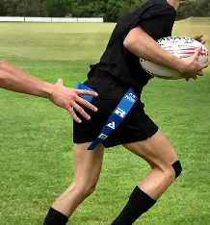  Playdough Monster  &  DIY Chocolate apple with a range of toppings  Tag Rugby | 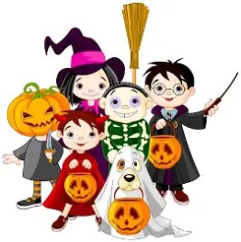  Spooky Halloween Disco  &  Face painting | 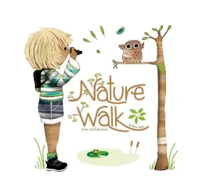  Nature walk and leaf collecting  DIY Monster Wreath  &  3D Paper Pumpkin


Holiday Club
Monday 26th October 2026 – Friday 30th October 2026
8am – 5pm for children aged 4-11
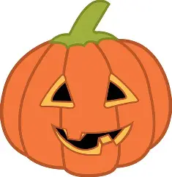
Party Game - Mummy wrap race, witch says, Pin the face on the Pumkin and lots more!
Team game, tag, hide and seek and much more!
Safety Darts

